1 run......

Downloading: 100%

464/464 [00:00<00:00, 12.7kB/s]

Downloading: 100%

270M/270M [00:08<00:00, 32.7MB/s]

training 1 epoch...

43.48691487312317 seconds used......

1 training finished! average train loss: 2.0268241622868706

total clf loss: 135.32975590229034 total adv loss: 70.15916562080383

evaluating...

Confusion matrix, without normalization

[[ 439 66 268]

[ 131 131 168]

[ 368 117 1844]]

Normalized confusion matrix

[[0.56791721 0.08538163 0.34670116]

[0.30465116 0.30465116 0.39069767]

[0.15800773 0.05023615 0.79175612]]

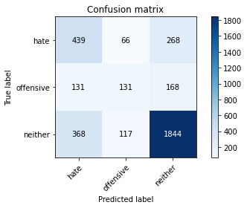

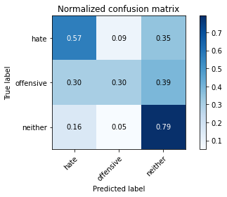

precision recall f1-score support

hate 0.47 0.57 0.51 773

offensive 0.42 0.30 0.35 430

neither 0.81 0.79 0.80 2329

accuracy 0.68 3532

macro avg 0.56 0.55 0.56 3532

weighted avg 0.69 0.68 0.68 3532

average eval_loss: 0.7835380765004346, accuracy: 0.6834654586636466

training 2 epoch...

42.67762064933777 seconds used......

2 training finished! average train loss: 1.462815927232013

total clf loss: 96.10096222162247 total adv loss: 51.42100189626217

evaluating...

Confusion matrix, without normalization

[[ 487 94 192]

[ 135 180 115]

[ 464 158 1707]]

Normalized confusion matrix

[[0.63001294 0.12160414 0.24838292]

[0.31395349 0.41860465 0.26744186]

[0.19922714 0.06784027 0.73293259]]

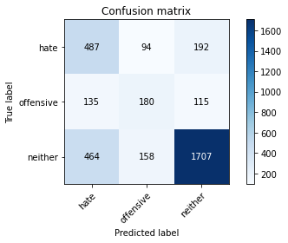

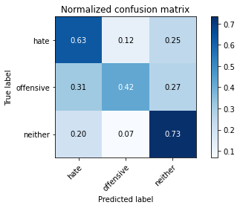

precision recall f1-score support

hate 0.45 0.63 0.52 773

offensive 0.42 0.42 0.42 430

neither 0.85 0.73 0.79 2329

accuracy 0.67 3532

macro avg 0.57 0.59 0.58 3532

weighted avg 0.71 0.67 0.68 3532

average eval_loss: 0.7756539990672957, accuracy: 0.6721404303510758

training 3 epoch...

42.733094453811646 seconds used......

3 training finished! average train loss: 0.9619876308476224

total clf loss: 67.46157643198967 total adv loss: 31.684370897710323

evaluating...

Confusion matrix, without normalization

[[ 454 81 238]

[ 125 173 132]

[ 381 160 1788]]

Normalized confusion matrix

[[0.58732212 0.10478655 0.30789133]

[0.29069767 0.40232558 0.30697674]

[0.16358952 0.06869901 0.76771146]]

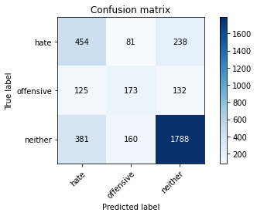

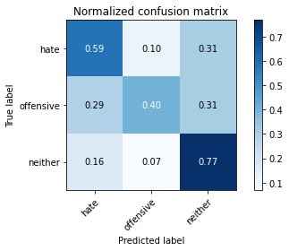

precision recall f1-score support

hate 0.47 0.59 0.52 773

offensive 0.42 0.40 0.41 430

neither 0.83 0.77 0.80 2329

accuracy 0.68 3532

macro avg 0.57 0.59 0.58 3532

weighted avg 0.70 0.68 0.69 3532

average eval_loss: 0.7827967545070217, accuracy: 0.6837485843714609

training 4 epoch...

42.65608334541321 seconds used......

4 training finished! average train loss: 0.49694476955953765

total clf loss: 41.834197632968426 total adv loss: 12.875145564321429

evaluating...

Confusion matrix, without normalization

[[ 324 164 285]

[ 68 220 142]

[ 247 203 1879]]

Normalized confusion matrix

[[0.41914618 0.21216041 0.3686934 ]

[0.15813953 0.51162791 0.33023256]

[0.1060541 0.08716187 0.80678403]]

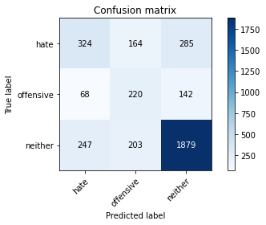

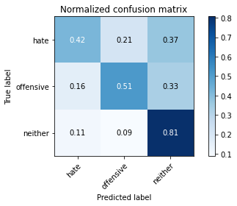

precision recall f1-score support

hate 0.51 0.42 0.46 773

offensive 0.37 0.51 0.43 430

neither 0.81 0.81 0.81 2329

accuracy 0.69 3532

macro avg 0.57 0.58 0.57 3532

weighted avg 0.69 0.69 0.69 3532

average eval_loss: 0.8785511159290702, accuracy: 0.6860135900339751

training 5 epoch...

42.630533933639526 seconds used......

5 training finished! average train loss: 0.2636512619004968

total clf loss: 27.492059241980314 total adv loss: 4.1822562265297165

evaluating...

Confusion matrix, without normalization

[[ 453 108 212]

[ 115 191 124]

[ 427 162 1740]]

Normalized confusion matrix

[[0.58602846 0.13971539 0.27425614]

[0.26744186 0.44418605 0.28837209]

[0.18334049 0.06955775 0.74710176]]

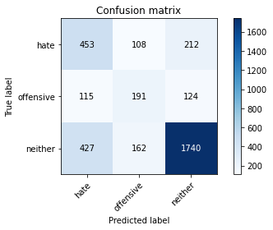

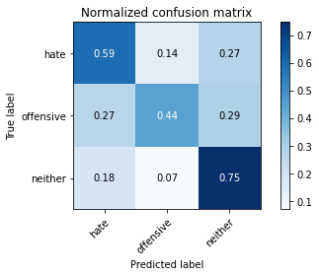

precision recall f1-score support

hate 0.46 0.59 0.51 773

offensive 0.41 0.44 0.43 430

neither 0.84 0.75 0.79 2329

accuracy 0.67 3532

macro avg 0.57 0.59 0.58 3532

weighted avg 0.70 0.67 0.69 3532

average eval_loss: 0.9653826355934143, accuracy: 0.6749716874292185

training 6 epoch...

42.62170433998108 seconds used......

6 training finished! average train loss: 0.19791273827500203

total clf loss: 20.311076221987605 total adv loss: 3.3025281535519753

evaluating...

Confusion matrix, without normalization

[[ 451 88 234]

[ 118 180 132]

[ 389 153 1787]]

Normalized confusion matrix

[[0.58344114 0.11384217 0.30271669]

[0.2744186 0.41860465 0.30697674]

[0.16702447 0.06569343 0.7672821 ]]

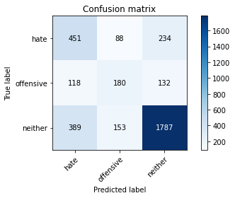

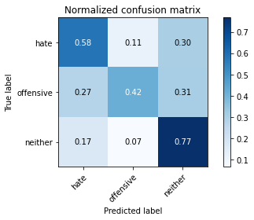

precision recall f1-score support

hate 0.47 0.58 0.52 773

offensive 0.43 0.42 0.42 430

neither 0.83 0.77 0.80 2329

accuracy 0.68 3532

macro avg 0.58 0.59 0.58 3532

weighted avg 0.70 0.68 0.69 3532

average eval_loss: 1.001126096326079, accuracy: 0.6845979614949037

training 7 epoch...

42.65883731842041 seconds used......

7 training finished! average train loss: 0.1500581340480815

total clf loss: 14.56391030177474 total adv loss: 2.921997972385725

evaluating...

Confusion matrix, without normalization

[[ 459 74 240]

[ 144 162 124]

[ 403 127 1799]]

Normalized confusion matrix

[[0.59379043 0.09573092 0.31047865]

[0.33488372 0.37674419 0.28837209]

[0.17303564 0.05452984 0.77243452]]

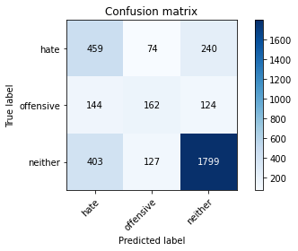

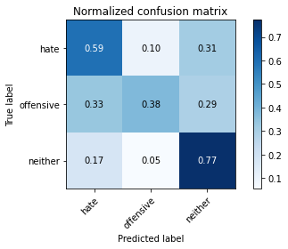

precision recall f1-score support

hate 0.46 0.59 0.52 773

offensive 0.45 0.38 0.41 430

neither 0.83 0.77 0.80 2329

accuracy 0.69 3532

macro avg 0.58 0.58 0.58 3532

weighted avg 0.70 0.69 0.69 3532

average eval_loss: 1.1156694529588613, accuracy: 0.6851642129105323

training 8 epoch...

42.81253719329834 seconds used......

8 training finished! average train loss: 0.08158464740742655

total clf loss: 9.232743480242789 total adv loss: 0.9313842680412563

evaluating...

Confusion matrix, without normalization

[[ 521 57 195]

[ 170 147 113]

[ 514 114 1701]]

Normalized confusion matrix

[[0.67399741 0.07373868 0.25226391]

[0.39534884 0.34186047 0.2627907 ]

[0.22069558 0.04894805 0.73035638]]

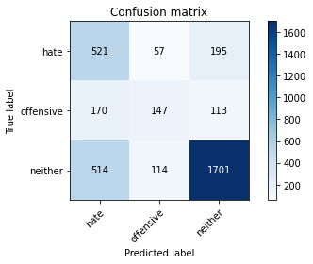

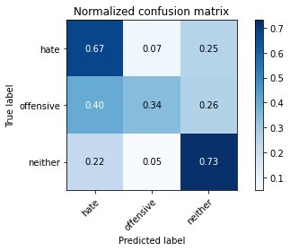

precision recall f1-score support

hate 0.43 0.67 0.53 773

offensive 0.46 0.34 0.39 430

neither 0.85 0.73 0.78 2329

accuracy 0.67 3532

macro avg 0.58 0.58 0.57 3532

weighted avg 0.71 0.67 0.68 3532

average eval_loss: 1.2161017365038058, accuracy: 0.6707248018120046

training 9 epoch...

42.7619104385376 seconds used......

9 training finished! average train loss: 0.047473098849877715

total clf loss: 5.898006066214293 total adv loss: 0.2791676766993305

evaluating...

Confusion matrix, without normalization

[[ 409 92 272]

[ 111 184 135]

[ 309 166 1854]]

Normalized confusion matrix

[[0.52910737 0.11901682 0.35187581]

[0.25813953 0.42790698 0.31395349]

[0.13267497 0.07127523 0.79604981]]

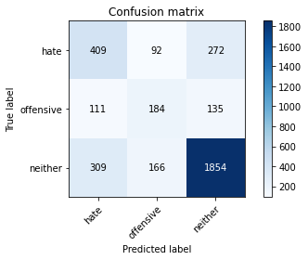

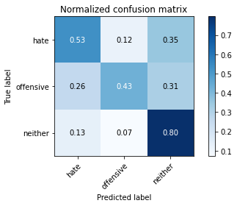

precision recall f1-score support

hate 0.49 0.53 0.51 773

offensive 0.42 0.43 0.42 430

neither 0.82 0.80 0.81 2329

accuracy 0.69 3532

macro avg 0.58 0.58 0.58 3532

weighted avg 0.70 0.69 0.70 3532

average eval_loss: 1.2637091310179167, accuracy: 0.6928086070215176

training 10 epoch...

42.7080864906311 seconds used......

10 training finished! average train loss: 0.0818377936974524

total clf loss: 5.854100321186706 total adv loss: 2.6379197916603516

evaluating...

Confusion matrix, without normalization

[[ 459 66 248]

[ 139 150 141]

[ 368 106 1855]]

Normalized confusion matrix

[[0.59379043 0.08538163 0.32082794]

[0.32325581 0.34883721 0.32790698]

[0.15800773 0.0455131 0.79647918]]

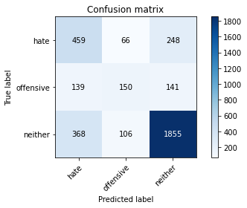

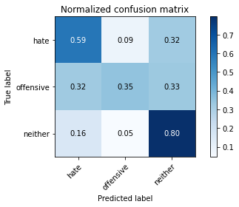

precision recall f1-score support

hate 0.48 0.59 0.53 773

offensive 0.47 0.35 0.40 430

neither 0.83 0.80 0.81 2329

accuracy 0.70 3532

macro avg 0.59 0.58 0.58 3532

weighted avg 0.71 0.70 0.70 3532

average eval_loss: 1.280091717839241, accuracy: 0.6976217440543602

2 run......

training 1 epoch...

42.6480987071991 seconds used......

1 training finished! average train loss: 2.045131568084745

total clf loss: 139.30779349803925 total adv loss: 69.41505068540573

evaluating...

Confusion matrix, without normalization

[[ 480 3 290]

[ 202 37 191]

[ 421 33 1875]]

Normalized confusion matrix

[[0.62095731 0.00388098 0.37516171]

[0.46976744 0.08604651 0.44418605]

[0.18076428 0.01416917 0.80506655]]

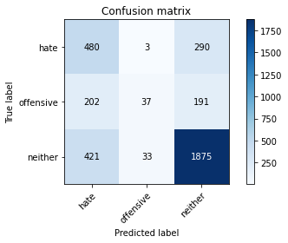

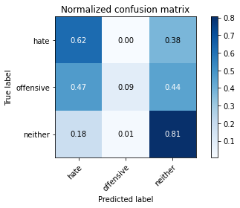

precision recall f1-score support

hate 0.44 0.62 0.51 773

offensive 0.51 0.09 0.15 430

neither 0.80 0.81 0.80 2329

accuracy 0.68 3532

macro avg 0.58 0.50 0.49 3532

weighted avg 0.68 0.68 0.66 3532

average eval_loss: 0.7745260693932657, accuracy: 0.6772366930917327

training 2 epoch...

42.69358587265015 seconds used......

2 training finished! average train loss: 1.484715362682062

total clf loss: 97.23635143041611 total adv loss: 52.34246839955449

evaluating...

Confusion matrix, without normalization

[[ 341 133 299]

[ 69 207 154]

[ 220 175 1934]]

Normalized confusion matrix

[[0.44113842 0.17205692 0.38680466]

[0.16046512 0.48139535 0.35813953]

[0.09446114 0.07513954 0.83039931]]

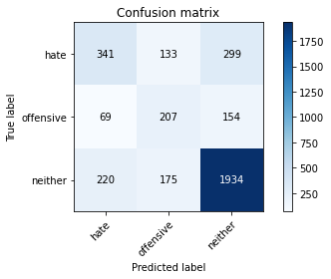

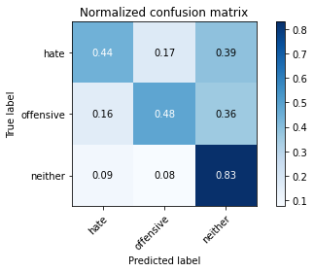

precision recall f1-score support

hate 0.54 0.44 0.49 773

offensive 0.40 0.48 0.44 430

neither 0.81 0.83 0.82 2329

accuracy 0.70 3532

macro avg 0.58 0.58 0.58 3532

weighted avg 0.70 0.70 0.70 3532

average eval_loss: 0.7184796750882251, accuracy: 0.702718006795017

training 3 epoch...

42.843465089797974 seconds used......

3 training finished! average train loss: 0.9203817870687035

total clf loss: 65.81465941667557 total adv loss: 29.67863206937909

evaluating...

Confusion matrix, without normalization

[[ 376 54 343]

[ 106 137 187]

[ 228 76 2025]]

Normalized confusion matrix

[[0.48641656 0.0698577 0.44372574]

[0.24651163 0.31860465 0.43488372]

[0.09789609 0.03263203 0.86947188]]

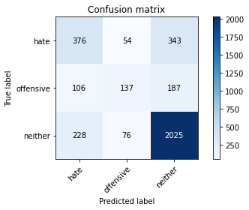

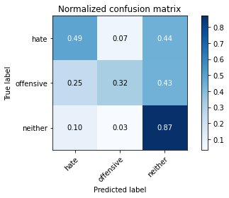

precision recall f1-score support

hate 0.53 0.49 0.51 773

offensive 0.51 0.32 0.39 430

neither 0.79 0.87 0.83 2329

accuracy 0.72 3532

macro avg 0.61 0.56 0.58 3532

weighted avg 0.70 0.72 0.71 3532

average eval_loss: 0.715310244405337, accuracy: 0.7185730464326161

training 4 epoch...

42.63512134552002 seconds used......

4 training finished! average train loss: 0.4707790829569978

total clf loss: 40.85146450996399 total adv loss: 11.587245400995016

evaluating...

Confusion matrix, without normalization

[[ 340 102 331]

[ 74 182 174]

[ 215 158 1956]]

Normalized confusion matrix

[[0.43984476 0.13195343 0.42820181]

[0.17209302 0.42325581 0.40465116]

[0.0923143 0.06784027 0.83984543]]

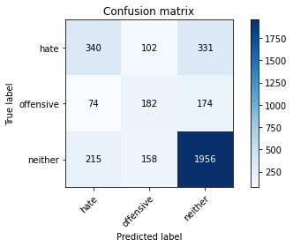

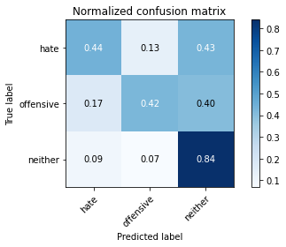

precision recall f1-score support

hate 0.54 0.44 0.49 773

offensive 0.41 0.42 0.42 430

neither 0.79 0.84 0.82 2329

accuracy 0.70 3532

macro avg 0.58 0.57 0.57 3532

weighted avg 0.69 0.70 0.70 3532

average eval_loss: 0.8456637678341677, accuracy: 0.70158550396376

training 5 epoch...

42.63896083831787 seconds used......

5 training finished! average train loss: 0.24822252112276413

total clf loss: 26.019024908542633 total adv loss: 3.8696190042683156

evaluating...

Confusion matrix, without normalization

[[ 373 115 285]

[ 90 202 138]

[ 279 175 1875]]

Normalized confusion matrix

[[0.48253558 0.14877102 0.3686934 ]

[0.20930233 0.46976744 0.32093023]

[0.1197939 0.07513954 0.80506655]]

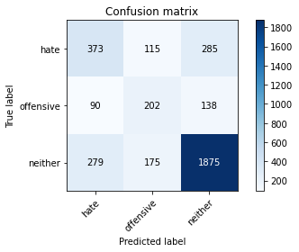

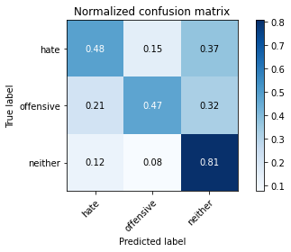

precision recall f1-score support

hate 0.50 0.48 0.49 773

offensive 0.41 0.47 0.44 430

neither 0.82 0.81 0.81 2329

accuracy 0.69 3532

macro avg 0.58 0.59 0.58 3532

weighted avg 0.70 0.69 0.70 3532

average eval_loss: 0.9314745690694637, accuracy: 0.6936579841449604

training 6 epoch...

42.77013182640076 seconds used......

6 training finished! average train loss: 0.16072756482069106

total clf loss: 17.28432898595929 total adv loss: 2.2873099481657846

evaluating...

Confusion matrix, without normalization

[[ 462 97 214]

[ 124 186 120]

[ 431 172 1726]]

Normalized confusion matrix

[[0.59767141 0.12548512 0.27684347]

[0.28837209 0.43255814 0.27906977]

[0.18505796 0.07385144 0.7410906 ]]

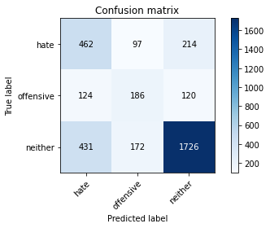

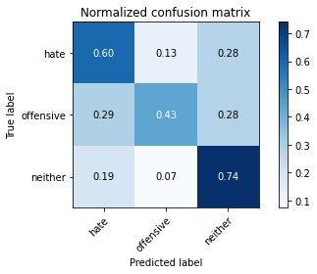

precision recall f1-score support

hate 0.45 0.60 0.52 773

offensive 0.41 0.43 0.42 430

neither 0.84 0.74 0.79 2329

accuracy 0.67 3532

macro avg 0.57 0.59 0.57 3532

weighted avg 0.70 0.67 0.68 3532

average eval_loss: 1.0918633535420155, accuracy: 0.6721404303510758

training 7 epoch...

42.61252951622009 seconds used......

7 training finished! average train loss: 0.09087571573635454

total clf loss: 11.32880081795156 total adv loss: 0.5151482614601264

evaluating...

Confusion matrix, without normalization

[[ 346 128 299]

[ 79 193 158]

[ 235 192 1902]]

Normalized confusion matrix

[[0.44760673 0.16558862 0.38680466]

[0.18372093 0.44883721 0.36744186]

[0.10090167 0.08243881 0.81665951]]

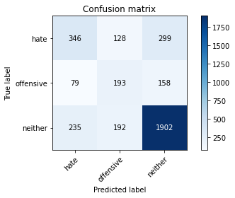

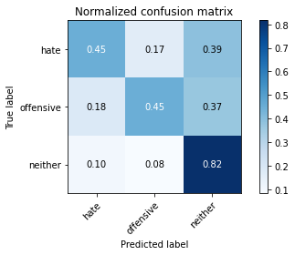

precision recall f1-score support

hate 0.52 0.45 0.48 773

offensive 0.38 0.45 0.41 430

neither 0.81 0.82 0.81 2329

accuracy 0.69 3532

macro avg 0.57 0.57 0.57 3532

weighted avg 0.69 0.69 0.69 3532

average eval_loss: 1.1355116810165555, accuracy: 0.6911098527746319

training 8 epoch...

42.6764030456543 seconds used......

8 training finished! average train loss: 0.11725636850357712

total clf loss: 9.038719033822417 total adv loss: 3.454073543780396

evaluating...

Confusion matrix, without normalization

[[ 486 69 218]

[ 144 154 132]

[ 418 132 1779]]

Normalized confusion matrix

[[0.62871928 0.08926261 0.28201811]

[0.33488372 0.35813953 0.30697674]

[0.17947617 0.05667669 0.76384714]]

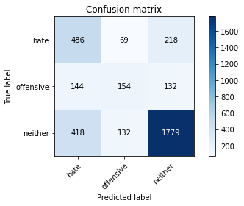

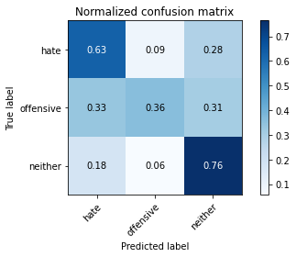

precision recall f1-score support

hate 0.46 0.63 0.53 773

offensive 0.43 0.36 0.39 430

neither 0.84 0.76 0.80 2329

accuracy 0.68 3532

macro avg 0.58 0.58 0.57 3532

weighted avg 0.71 0.68 0.69 3532

average eval_loss: 1.1682682257924377, accuracy: 0.684881087202718

training 9 epoch...

42.681113719940186 seconds used......

9 training finished! average train loss: 0.07854392637005624

total clf loss: 6.660983803682029 total adv loss: 2.0104951194589376

evaluating...

Confusion matrix, without normalization

[[ 383 108 282]

[ 93 175 162]

[ 280 158 1891]]

Normalized confusion matrix

[[0.49547219 0.13971539 0.36481242]

[0.21627907 0.40697674 0.37674419]

[0.12022327 0.06784027 0.81193645]]

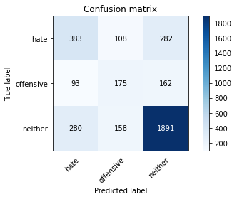

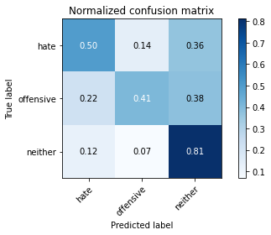

precision recall f1-score support

hate 0.51 0.50 0.50 773

offensive 0.40 0.41 0.40 430

neither 0.81 0.81 0.81 2329

accuracy 0.69 3532

macro avg 0.57 0.57 0.57 3532

weighted avg 0.69 0.69 0.69 3532

average eval_loss: 1.2516774762905925, accuracy: 0.6933748584371461

training 10 epoch...

42.66995167732239 seconds used......

10 training finished! average train loss: 0.07286398761275717

total clf loss: 5.781563566066325 total adv loss: 2.0639693931916554

evaluating...

Confusion matrix, without normalization

[[ 432 78 263]

[ 128 155 147]

[ 347 143 1839]]

Normalized confusion matrix

[[0.55886158 0.10090556 0.34023286]

[0.29767442 0.36046512 0.34186047]

[0.14899098 0.06139974 0.78960927]]

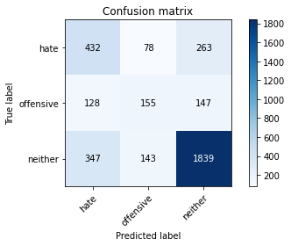

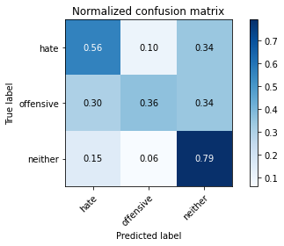

precision recall f1-score support

hate 0.48 0.56 0.51 773

offensive 0.41 0.36 0.38 430

neither 0.82 0.79 0.80 2329

accuracy 0.69 3532

macro avg 0.57 0.57 0.57 3532

weighted avg 0.69 0.69 0.69 3532

average eval_loss: 1.2676085725763424, accuracy: 0.6868629671574179

3 run......

training 1 epoch...

42.646037578582764 seconds used......

1 training finished! average train loss: 2.0359705853111603

total clf loss: 135.61850661039352 total adv loss: 70.63674630224705

evaluating...

Confusion matrix, without normalization

[[ 455 14 304]

[ 186 61 183]

[ 356 48 1925]]

Normalized confusion matrix

[[0.58861578 0.01811125 0.39327296]

[0.43255814 0.14186047 0.4255814 ]

[0.1528553 0.0206097 0.82653499]]

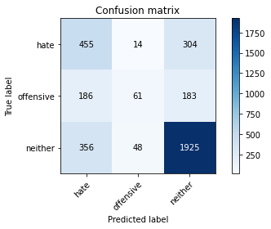

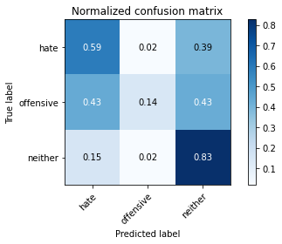

precision recall f1-score support

hate 0.46 0.59 0.51 773

offensive 0.50 0.14 0.22 430

neither 0.80 0.83 0.81 2329

accuracy 0.69 3532

macro avg 0.58 0.52 0.52 3532

weighted avg 0.69 0.69 0.67 3532

average eval_loss: 0.7615748610200181, accuracy: 0.6911098527746319

training 2 epoch...

42.66205334663391 seconds used......

2 training finished! average train loss: 1.4716151812497307

total clf loss: 95.60640987753868 total adv loss: 52.26662750542164

evaluating...

Confusion matrix, without normalization

[[ 431 63 279]

[ 127 157 146]

[ 312 124 1893]]

Normalized confusion matrix

[[0.55756792 0.08150065 0.36093144]

[0.29534884 0.36511628 0.33953488]

[0.13396307 0.05324173 0.81279519]]

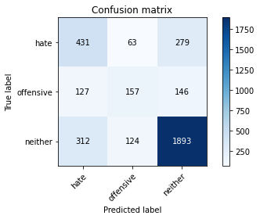

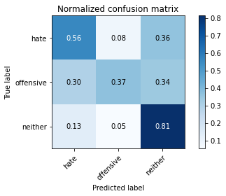

precision recall f1-score support

hate 0.50 0.56 0.52 773

offensive 0.46 0.37 0.41 430

neither 0.82 0.81 0.81 2329

accuracy 0.70 3532

macro avg 0.59 0.58 0.58 3532

weighted avg 0.70 0.70 0.70 3532

average eval_loss: 0.7159306519785843, accuracy: 0.7024348810872028

training 3 epoch...

42.65769863128662 seconds used......

3 training finished! average train loss: 0.9134494456298211

total clf loss: 64.71205952763557 total adv loss: 29.758532486855984

evaluating...

Confusion matrix, without normalization

[[ 382 123 268]

[ 81 212 137]

[ 274 185 1870]]

Normalized confusion matrix

[[0.49417853 0.15912031 0.34670116]

[0.18837209 0.49302326 0.31860465]

[0.11764706 0.07943323 0.80291971]]

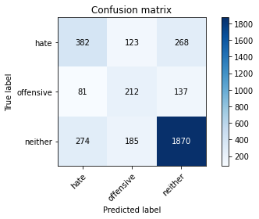

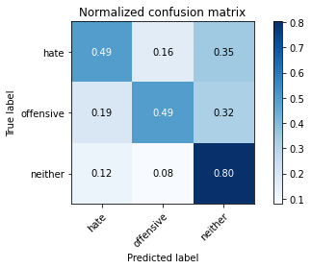

precision recall f1-score support

hate 0.52 0.49 0.51 773

offensive 0.41 0.49 0.45 430

neither 0.82 0.80 0.81 2329

accuracy 0.70 3532

macro avg 0.58 0.60 0.59 3532

weighted avg 0.71 0.70 0.70 3532

average eval_loss: 0.7592477259662865, accuracy: 0.6976217440543602

training 4 epoch...

42.59291481971741 seconds used......

4 training finished! average train loss: 0.47809510382221027

total clf loss: 40.29465449601412 total adv loss: 12.363139930646867

evaluating...

Confusion matrix, without normalization

[[ 347 149 277]

[ 72 217 141]

[ 241 223 1865]]

Normalized confusion matrix

[[0.44890039 0.1927555 0.35834411]

[0.16744186 0.50465116 0.32790698]

[0.10347789 0.09574925 0.80077286]]

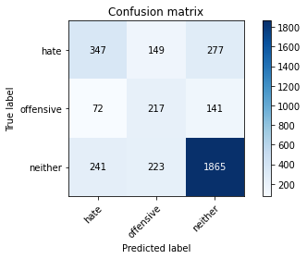

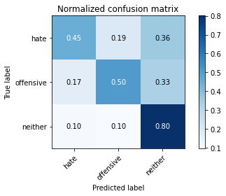

precision recall f1-score support

hate 0.53 0.45 0.48 773

offensive 0.37 0.50 0.43 430

neither 0.82 0.80 0.81 2329

accuracy 0.69 3532

macro avg 0.57 0.58 0.57 3532

weighted avg 0.70 0.69 0.69 3532

average eval_loss: 0.8434610328095108, accuracy: 0.6877123442808607

training 5 epoch...

42.6203031539917 seconds used......

5 training finished! average train loss: 0.23926909796564894

total clf loss: 26.264404099434614 total adv loss: 3.138096578375553

evaluating...

Confusion matrix, without normalization

[[ 426 113 234]

[ 101 195 134]

[ 361 167 1801]]

Normalized confusion matrix

[[0.55109961 0.1461837 0.30271669]

[0.23488372 0.45348837 0.31162791]

[0.15500215 0.07170459 0.77329326]]

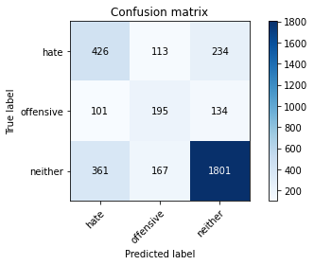

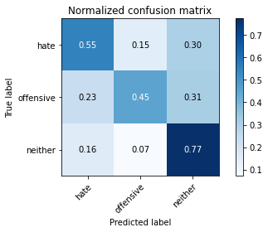

precision recall f1-score support

hate 0.48 0.55 0.51 773

offensive 0.41 0.45 0.43 430

neither 0.83 0.77 0.80 2329

accuracy 0.69 3532

macro avg 0.57 0.59 0.58 3532

weighted avg 0.70 0.69 0.69 3532

average eval_loss: 0.9378565575106669, accuracy: 0.6857304643261608

training 6 epoch...

42.69784426689148 seconds used......

6 training finished! average train loss: 0.14328360119286707

total clf loss: 16.590469431132078 total adv loss: 1.4480501640173316

evaluating...

Confusion matrix, without normalization

[[ 380 143 250]

[ 93 214 123]

[ 309 229 1791]]

Normalized confusion matrix

[[0.4915912 0.18499353 0.32341527]

[0.21627907 0.49767442 0.28604651]

[0.13267497 0.09832546 0.76899957]]

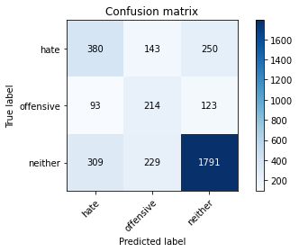

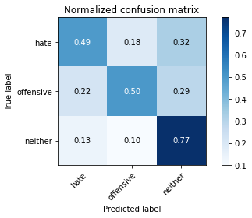

precision recall f1-score support

hate 0.49 0.49 0.49 773

offensive 0.37 0.50 0.42 430

neither 0.83 0.77 0.80 2329

accuracy 0.68 3532

macro avg 0.56 0.59 0.57 3532

weighted avg 0.70 0.68 0.68 3532

average eval_loss: 1.064252793115411, accuracy: 0.6752548131370328

training 7 epoch...

42.63441586494446 seconds used......

7 training finished! average train loss: 0.12149269372800037

total clf loss: 11.772953278385103 total adv loss: 2.3750265052385657

evaluating...

Confusion matrix, without normalization

[[ 435 145 193]

[ 108 219 103]

[ 431 282 1616]]

Normalized confusion matrix

[[0.56274256 0.18758085 0.24967658]

[0.25116279 0.50930233 0.23953488]

[0.18505796 0.12108201 0.69386003]]

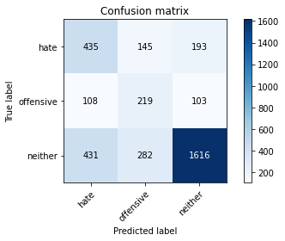

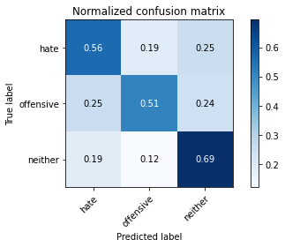

precision recall f1-score support

hate 0.45 0.56 0.50 773

offensive 0.34 0.51 0.41 430

neither 0.85 0.69 0.76 2329

accuracy 0.64 3532

macro avg 0.54 0.59 0.56 3532

weighted avg 0.70 0.64 0.66 3532

average eval_loss: 1.270288938772207, accuracy: 0.6426953567383918

training 8 epoch...

42.64991998672485 seconds used......

8 training finished! average train loss: 0.08031277888564065

total clf loss: 7.834453258663416 total adv loss: 1.5440423656582425

evaluating...

Confusion matrix, without normalization

[[ 438 149 186]

[ 99 225 106]

[ 433 243 1653]]

Normalized confusion matrix

[[0.56662354 0.1927555 0.24062096]

[0.23023256 0.52325581 0.24651163]

[0.1859167 0.10433663 0.70974667]]

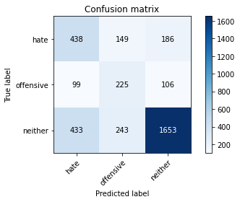

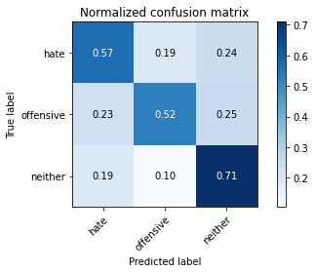

precision recall f1-score support

hate 0.45 0.57 0.50 773

offensive 0.36 0.52 0.43 430

neither 0.85 0.71 0.77 2329

accuracy 0.66 3532

macro avg 0.56 0.60 0.57 3532

weighted avg 0.70 0.66 0.67 3532

average eval_loss: 1.3570019274444904, accuracy: 0.6557191392978482

training 9 epoch...

42.66795825958252 seconds used......

9 training finished! average train loss: 0.051465900816872495

total clf loss: 5.040054626297206 total adv loss: 0.9796539480103093

evaluating...

Confusion matrix, without normalization

[[ 400 115 258]

[ 100 200 130]

[ 283 188 1858]]

Normalized confusion matrix

[[0.51746442 0.14877102 0.33376455]

[0.23255814 0.46511628 0.30232558]

[0.12151138 0.08072134 0.79776728]]

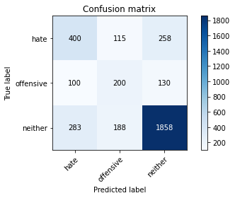

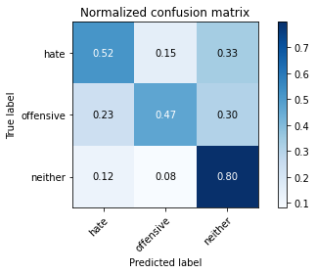

precision recall f1-score support

hate 0.51 0.52 0.51 773

offensive 0.40 0.47 0.43 430

neither 0.83 0.80 0.81 2329

accuracy 0.70 3532

macro avg 0.58 0.59 0.59 3532

weighted avg 0.71 0.70 0.70 3532

average eval_loss: 1.2717266399308114, accuracy: 0.6959229898074745

training 10 epoch...

42.63127684593201 seconds used......

10 training finished! average train loss: 0.0775681137730477

total clf loss: 4.671767985215411 total adv loss: 2.9387477116697482

evaluating...

Confusion matrix, without normalization

[[ 414 111 248]

[ 100 204 126]

[ 327 188 1814]]

Normalized confusion matrix

[[0.53557568 0.14359638 0.32082794]

[0.23255814 0.4744186 0.29302326]

[0.14040361 0.08072134 0.77887505]]

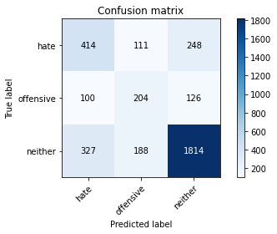

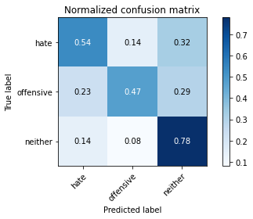

precision recall f1-score support

hate 0.49 0.54 0.51 773

offensive 0.41 0.47 0.44 430

neither 0.83 0.78 0.80 2329

accuracy 0.69 3532

macro avg 0.58 0.60 0.58 3532

weighted avg 0.70 0.69 0.70 3532

average eval_loss: 1.2853431006272633, accuracy: 0.6885617214043035

4 run......

training 1 epoch...

42.6119749546051 seconds used......

1 training finished! average train loss: 2.054934023934252

total clf loss: 138.1322203874588 total adv loss: 70.66940347850323

evaluating...

Confusion matrix, without normalization

[[ 431 84 258]

[ 111 142 177]

[ 387 174 1768]]

Normalized confusion matrix

[[0.55756792 0.10866753 0.33376455]

[0.25813953 0.33023256 0.41162791]

[0.16616574 0.07471018 0.75912409]]

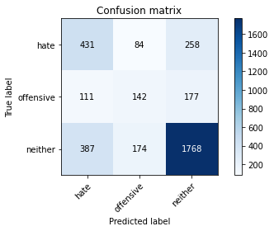

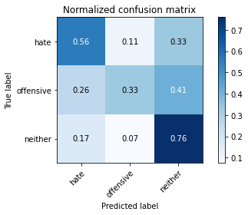

precision recall f1-score support

hate 0.46 0.56 0.51 773

offensive 0.35 0.33 0.34 430

neither 0.80 0.76 0.78 2329

accuracy 0.66 3532

macro avg 0.54 0.55 0.54 3532

weighted avg 0.67 0.66 0.67 3532

average eval_loss: 0.7847793964342883, accuracy: 0.662797281993205

training 2 epoch...

42.632275104522705 seconds used......

2 training finished! average train loss: 1.4716708616298788

total clf loss: 95.59036684036255 total adv loss: 52.27843515574932

evaluating...

Confusion matrix, without normalization

[[ 373 109 291]

[ 83 190 157]

[ 259 142 1928]]

Normalized confusion matrix

[[0.48253558 0.14100906 0.37645537]

[0.19302326 0.44186047 0.36511628]

[0.11120653 0.06097037 0.8278231 ]]

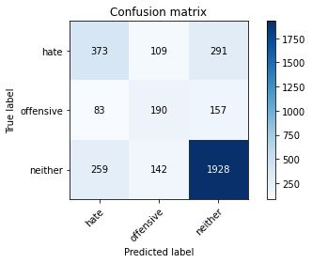

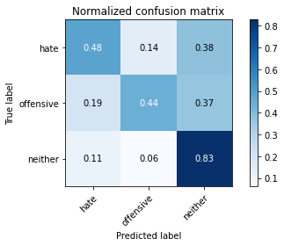

precision recall f1-score support

hate 0.52 0.48 0.50 773

offensive 0.43 0.44 0.44 430

neither 0.81 0.83 0.82 2329

accuracy 0.71 3532

macro avg 0.59 0.58 0.59 3532

weighted avg 0.70 0.71 0.70 3532

average eval_loss: 0.7117479662437224, accuracy: 0.7052661381653454

training 3 epoch...

42.648873805999756 seconds used......

3 training finished! average train loss: 0.914198511006201

total clf loss: 65.5137664526701 total adv loss: 29.408615654334426

evaluating...

Confusion matrix, without normalization

[[ 352 119 302]

[ 85 195 150]

[ 243 171 1915]]

Normalized confusion matrix

[[0.45536869 0.15394567 0.39068564]

[0.19767442 0.45348837 0.34883721]

[0.10433663 0.07342207 0.82224131]]

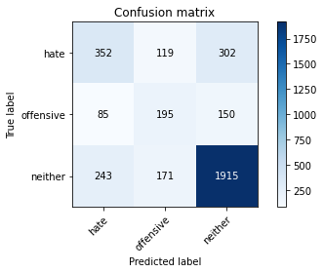

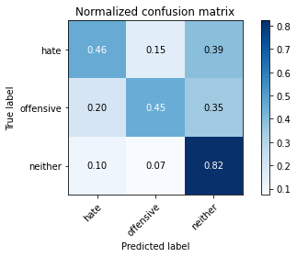

precision recall f1-score support

hate 0.52 0.46 0.48 773

offensive 0.40 0.45 0.43 430

neither 0.81 0.82 0.82 2329

accuracy 0.70 3532

macro avg 0.58 0.58 0.58 3532

weighted avg 0.70 0.70 0.70 3532

average eval_loss: 0.7329724639822535, accuracy: 0.6970554926387316

training 4 epoch...

42.61178398132324 seconds used......

4 training finished! average train loss: 0.44513951784328504

total clf loss: 40.015784278512 total adv loss: 10.261595150572248

evaluating...

Confusion matrix, without normalization

[[ 360 140 273]

[ 75 218 137]

[ 259 208 1862]]

Normalized confusion matrix

[[0.46571798 0.18111255 0.35316947]

[0.1744186 0.50697674 0.31860465]

[0.11120653 0.08930872 0.79948476]]

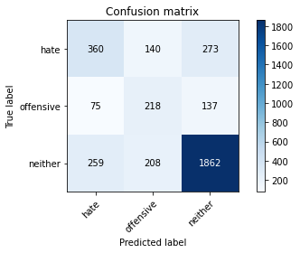

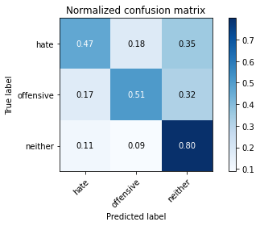

precision recall f1-score support

hate 0.52 0.47 0.49 773

offensive 0.39 0.51 0.44 430

neither 0.82 0.80 0.81 2329

accuracy 0.69 3532

macro avg 0.57 0.59 0.58 3532

weighted avg 0.70 0.69 0.69 3532

average eval_loss: 0.8586978494784253, accuracy: 0.6908267270668177

training 5 epoch...

42.653440713882446 seconds used......

5 training finished! average train loss: 0.27441516211804223

total clf loss: 27.25976327434182 total adv loss: 5.030349350796314

evaluating...

Confusion matrix, without normalization

[[ 396 64 313]

[ 118 149 163]

[ 248 98 1983]]

Normalized confusion matrix

[[0.51228978 0.08279431 0.40491591]

[0.2744186 0.34651163 0.37906977]

[0.10648347 0.04207815 0.85143839]]

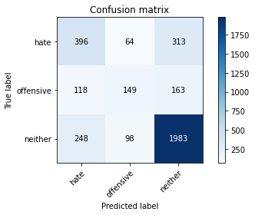

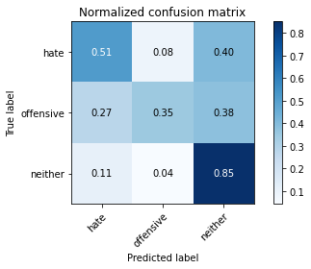

precision recall f1-score support

hate 0.52 0.51 0.52 773

offensive 0.48 0.35 0.40 430

neither 0.81 0.85 0.83 2329

accuracy 0.72 3532

macro avg 0.60 0.57 0.58 3532

weighted avg 0.70 0.72 0.71 3532

average eval_loss: 0.8880634311228822, accuracy: 0.7157417893544734

training 6 epoch...

42.624741315841675 seconds used......

6 training finished! average train loss: 0.1502565239857444

total clf loss: 17.56967280060053 total adv loss: 1.4326071935356595

evaluating...

Confusion matrix, without normalization

[[ 371 122 280]

[ 88 203 139]

[ 263 178 1888]]

Normalized confusion matrix

[[0.47994825 0.15782665 0.3622251 ]

[0.20465116 0.47209302 0.32325581]

[0.112924 0.07642765 0.81064835]]

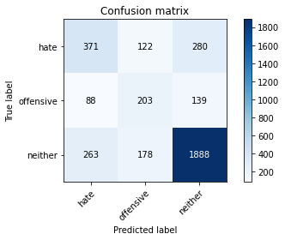

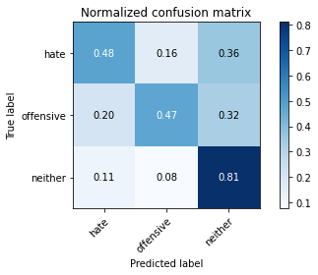

precision recall f1-score support

hate 0.51 0.48 0.50 773

offensive 0.40 0.47 0.44 430

neither 0.82 0.81 0.81 2329

accuracy 0.70 3532

macro avg 0.58 0.59 0.58 3532

weighted avg 0.70 0.70 0.70 3532

average eval_loss: 1.0271138858660467, accuracy: 0.6970554926387316

training 7 epoch...

42.62834644317627 seconds used......

7 training finished! average train loss: 0.1511974981164231

total clf loss: 13.705361445434391 total adv loss: 3.428749146174596

evaluating...

Confusion matrix, without normalization

[[ 446 140 187]

[ 116 211 103]

[ 425 233 1671]]

Normalized confusion matrix

[[0.57697283 0.18111255 0.24191462]

[0.26976744 0.49069767 0.23953488]

[0.18248175 0.10004294 0.71747531]]

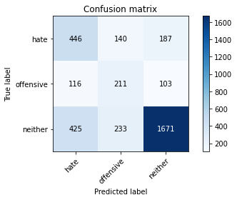

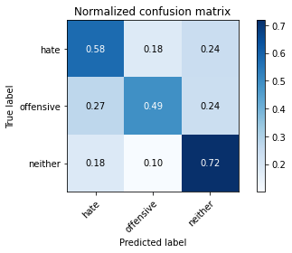

precision recall f1-score support

hate 0.45 0.58 0.51 773

offensive 0.36 0.49 0.42 430

neither 0.85 0.72 0.78 2329

accuracy 0.66 3532

macro avg 0.56 0.60 0.57 3532

weighted avg 0.70 0.66 0.68 3532

average eval_loss: 1.2048430804815669, accuracy: 0.6591166477916195

training 8 epoch...

42.59037947654724 seconds used......

8 training finished! average train loss: 0.11656625010757982

total clf loss: 10.41059441305697 total adv loss: 2.7212077831491115

evaluating...

Confusion matrix, without normalization

[[ 377 105 291]

[ 100 168 162]

[ 277 121 1931]]

Normalized confusion matrix

[[0.48771022 0.13583441 0.37645537]

[0.23255814 0.39069767 0.37674419]

[0.11893517 0.05195363 0.82911121]]

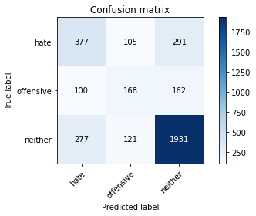

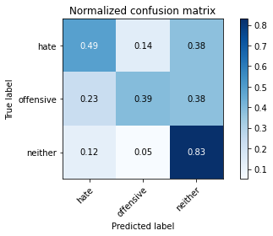

precision recall f1-score support

hate 0.50 0.49 0.49 773

offensive 0.43 0.39 0.41 430

neither 0.81 0.83 0.82 2329

accuracy 0.70 3532

macro avg 0.58 0.57 0.57 3532

weighted avg 0.70 0.70 0.70 3532

average eval_loss: 1.1023799868795159, accuracy: 0.7010192525481314

training 9 epoch...

42.60050129890442 seconds used......

9 training finished! average train loss: 0.052807308480088765

total clf loss: 5.78754871012643 total adv loss: 0.6971226190644302

evaluating...

Confusion matrix, without normalization

[[ 410 80 283]

[ 124 142 164]

[ 316 106 1907]]

Normalized confusion matrix

[[0.53040103 0.10349288 0.36610608]

[0.28837209 0.33023256 0.38139535]

[0.13568055 0.0455131 0.81880635]]

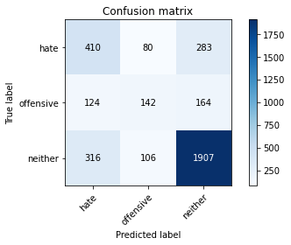

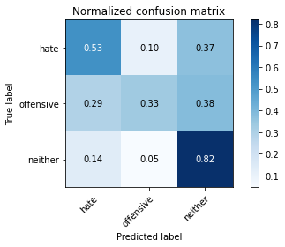

precision recall f1-score support

hate 0.48 0.53 0.51 773

offensive 0.43 0.33 0.37 430

neither 0.81 0.82 0.81 2329

accuracy 0.70 3532

macro avg 0.58 0.56 0.56 3532

weighted avg 0.69 0.70 0.69 3532

average eval_loss: 1.2094444428796822, accuracy: 0.6962061155152888

training 10 epoch...

42.635581970214844 seconds used......

10 training finished! average train loss: 0.038174743645975145

total clf loss: 3.471678763628006 total adv loss: 0.8600431956319881

evaluating...

Confusion matrix, without normalization

[[ 386 159 228]

[ 86 229 115]

[ 324 261 1744]]

Normalized confusion matrix

[[0.49935317 0.20569211 0.29495472]

[0.2 0.53255814 0.26744186]

[0.1391155 0.11206526 0.74881924]]

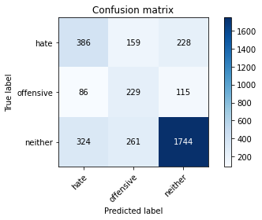

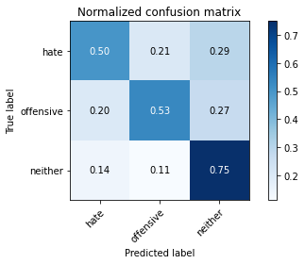

precision recall f1-score support

hate 0.48 0.50 0.49 773

offensive 0.35 0.53 0.42 430

neither 0.84 0.75 0.79 2329

accuracy 0.67 3532

macro avg 0.56 0.59 0.57 3532

weighted avg 0.70 0.67 0.68 3532

average eval_loss: 1.4369369725891425, accuracy: 0.6678935447338619

5 run......

training 1 epoch...

42.68694996833801 seconds used......

1 training finished! average train loss: 2.0525264345547733

total clf loss: 138.895239174366 total adv loss: 70.12417843937874

evaluating...

Confusion matrix, without normalization

[[ 451 46 276]

[ 165 107 158]

[ 361 115 1853]]

Normalized confusion matrix

[[0.58344114 0.05950841 0.35705045]

[0.38372093 0.24883721 0.36744186]

[0.15500215 0.04937742 0.79562044]]

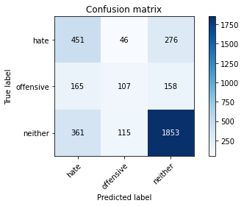

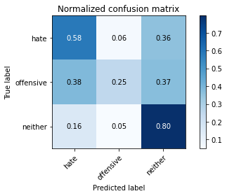

precision recall f1-score support

hate 0.46 0.58 0.52 773

offensive 0.40 0.25 0.31 430

neither 0.81 0.80 0.80 2329

accuracy 0.68 3532

macro avg 0.56 0.54 0.54 3532

weighted avg 0.68 0.68 0.68 3532

average eval_loss: 0.788221850233563, accuracy: 0.6826160815402038

training 2 epoch...

42.64557218551636 seconds used......

2 training finished! average train loss: 1.486792756792377

total clf loss: 96.89783126115799 total adv loss: 52.652991741895676

evaluating...

Confusion matrix, without normalization

[[ 370 115 288]

[ 87 204 139]

[ 253 199 1877]]

Normalized confusion matrix

[[0.47865459 0.14877102 0.37257439]

[0.20232558 0.4744186 0.32325581]

[0.10863031 0.0854444 0.80592529]]

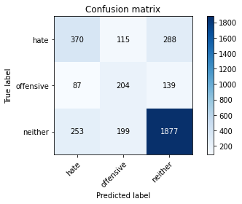

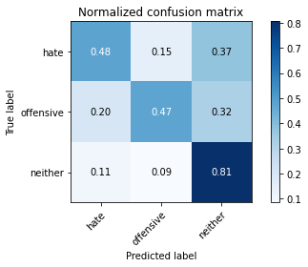

precision recall f1-score support

hate 0.52 0.48 0.50 773

offensive 0.39 0.47 0.43 430

neither 0.81 0.81 0.81 2329

accuracy 0.69 3532

macro avg 0.58 0.59 0.58 3532

weighted avg 0.70 0.69 0.70 3532

average eval_loss: 0.738116217703469, accuracy: 0.6939411098527747

training 3 epoch...

42.64453315734863 seconds used......

3 training finished! average train loss: 0.9421495332875672

total clf loss: 66.38109417259693 total adv loss: 30.87562100868672

evaluating...

Confusion matrix, without normalization

[[ 411 111 251]

[ 105 185 140]

[ 337 171 1821]]

Normalized confusion matrix

[[0.5316947 0.14359638 0.32470893]

[0.24418605 0.43023256 0.3255814 ]

[0.14469729 0.07342207 0.78188064]]

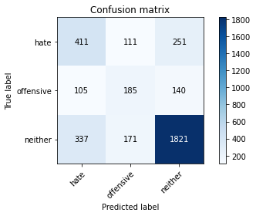

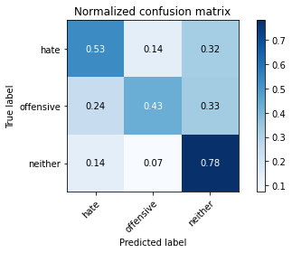

precision recall f1-score support

hate 0.48 0.53 0.51 773

offensive 0.40 0.43 0.41 430

neither 0.82 0.78 0.80 2329

accuracy 0.68 3532

macro avg 0.57 0.58 0.57 3532

weighted avg 0.70 0.68 0.69 3532

average eval_loss: 0.772446444815835, accuracy: 0.6843148357870895

training 4 epoch...

42.66103506088257 seconds used......

4 training finished! average train loss: 0.5246195879710072

total clf loss: 44.119425907731056 total adv loss: 13.614419036894105

evaluating...

Confusion matrix, without normalization

[[ 473 56 244]

[ 142 156 132]

[ 403 134 1792]]

Normalized confusion matrix

[[0.61190168 0.07244502 0.3156533 ]

[0.33023256 0.3627907 0.30697674]

[0.17303564 0.05753542 0.76942894]]

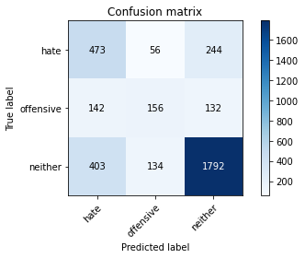

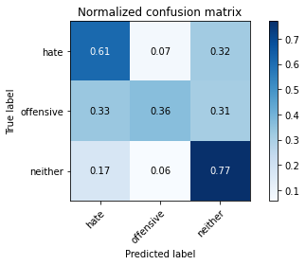

precision recall f1-score support

hate 0.46 0.61 0.53 773

offensive 0.45 0.36 0.40 430

neither 0.83 0.77 0.80 2329

accuracy 0.69 3532

macro avg 0.58 0.58 0.58 3532

weighted avg 0.70 0.69 0.69 3532

average eval_loss: 0.8492602506431483, accuracy: 0.6854473386183465

training 5 epoch...

42.611886978149414 seconds used......

5 training finished! average train loss: 0.269424415905686

total clf loss: 27.540750436484814 total adv loss: 4.55048505794548

evaluating...

Confusion matrix, without normalization

[[ 349 135 289]

[ 83 201 146]

[ 218 209 1902]]

Normalized confusion matrix

[[0.45148771 0.17464424 0.37386805]

[0.19302326 0.46744186 0.33953488]

[0.0936024 0.08973809 0.81665951]]

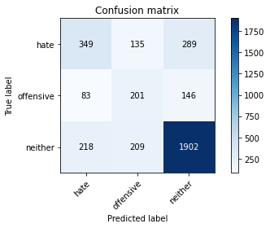

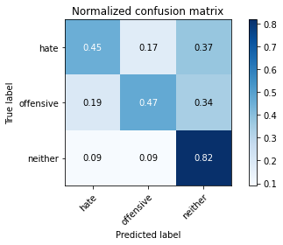

precision recall f1-score support

hate 0.54 0.45 0.49 773

offensive 0.37 0.47 0.41 430

neither 0.81 0.82 0.82 2329

accuracy 0.69 3532

macro avg 0.57 0.58 0.57 3532

weighted avg 0.70 0.69 0.70 3532

average eval_loss: 0.9381554556936867, accuracy: 0.6942242355605889

training 6 epoch...

42.61010003089905 seconds used......

6 training finished! average train loss: 0.18566559518084808

total clf loss: 20.310902629047632 total adv loss: 2.4698091399259283

evaluating...

Confusion matrix, without normalization

[[ 437 109 227]

[ 123 179 128]

[ 403 204 1722]]

Normalized confusion matrix

[[0.56532988 0.14100906 0.29366106]

[0.28604651 0.41627907 0.29767442]

[0.17303564 0.08759124 0.73937312]]

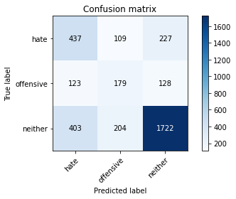

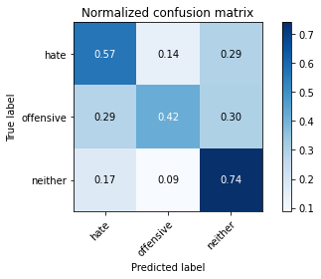

precision recall f1-score support

hate 0.45 0.57 0.50 773

offensive 0.36 0.42 0.39 430

neither 0.83 0.74 0.78 2329

accuracy 0.66 3532

macro avg 0.55 0.57 0.56 3532

weighted avg 0.69 0.66 0.67 3532

average eval_loss: 1.0863391789002608, accuracy: 0.6619479048697622

training 7 epoch...

42.661227226257324 seconds used......

7 training finished! average train loss: 0.1313973817125182

total clf loss: 13.835606730543077 total adv loss: 2.017218637967744

evaluating...

Confusion matrix, without normalization

[[ 476 56 241]

[ 163 134 133]

[ 435 114 1780]]

Normalized confusion matrix

[[0.61578266 0.07244502 0.31177232]

[0.37906977 0.31162791 0.30930233]

[0.18677544 0.04894805 0.76427651]]

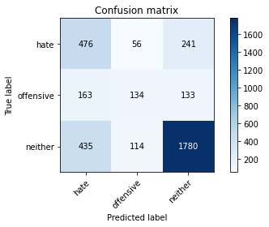

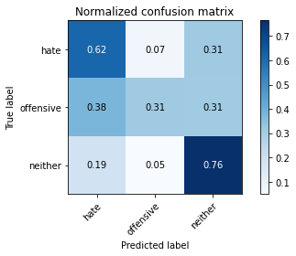

precision recall f1-score support

hate 0.44 0.62 0.52 773

offensive 0.44 0.31 0.37 430

neither 0.83 0.76 0.79 2329

accuracy 0.68 3532

macro avg 0.57 0.56 0.56 3532

weighted avg 0.70 0.68 0.68 3532

average eval_loss: 1.119623798477111, accuracy: 0.6766704416761042

training 8 epoch...

42.62315034866333 seconds used......

8 training finished! average train loss: 0.07294876924852896

total clf loss: 8.534638421144336 total adv loss: 0.6931970811892825

evaluating...

Confusion matrix, without normalization

[[ 451 109 213]

[ 132 183 115]

[ 445 196 1688]]

Normalized confusion matrix

[[0.58344114 0.14100906 0.27554981]

[0.30697674 0.4255814 0.26744186]

[0.19106913 0.08415629 0.72477458]]

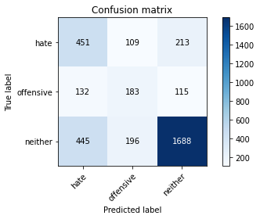

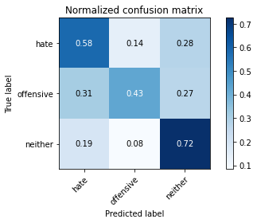

precision recall f1-score support

hate 0.44 0.58 0.50 773

offensive 0.38 0.43 0.40 430

neither 0.84 0.72 0.78 2329

accuracy 0.66 3532

macro avg 0.55 0.58 0.56 3532

weighted avg 0.69 0.66 0.67 3532

average eval_loss: 1.274582431814765, accuracy: 0.6574178935447339

training 9 epoch...

42.667837142944336 seconds used......

9 training finished! average train loss: 0.08588805991937132

total clf loss: 7.812321804929525 total adv loss: 1.9342271645559777

evaluating...

Confusion matrix, without normalization

[[ 423 106 244]

[ 127 182 121]

[ 339 190 1800]]

Normalized confusion matrix

[[0.54721863 0.13712807 0.3156533 ]

[0.29534884 0.42325581 0.28139535]

[0.14555603 0.08158008 0.77286389]]

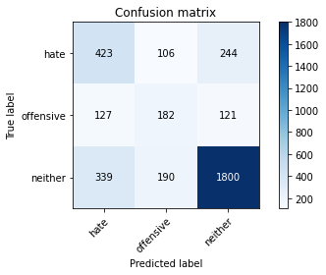

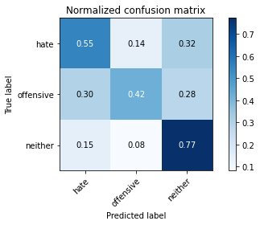

precision recall f1-score support

hate 0.48 0.55 0.51 773

offensive 0.38 0.42 0.40 430

neither 0.83 0.77 0.80 2329

accuracy 0.68 3532

macro avg 0.56 0.58 0.57 3532

weighted avg 0.70 0.68 0.69 3532

average eval_loss: 1.3024852493051755, accuracy: 0.6809173272933182

training 10 epoch...

42.67868232727051 seconds used......

10 training finished! average train loss: 0.0952642712954377

total clf loss: 6.822158877272159 total adv loss: 3.0668910617787333

evaluating...

Confusion matrix, without normalization

[[ 456 91 226]

[ 133 180 117]

[ 432 179 1718]]

Normalized confusion matrix

[[0.58990944 0.11772316 0.2923674 ]

[0.30930233 0.41860465 0.27209302]

[0.18548733 0.07685702 0.73765565]]

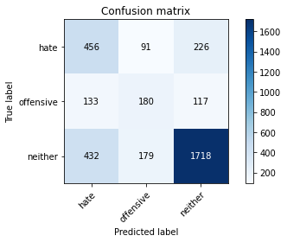

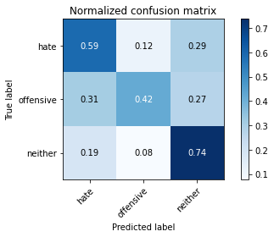

precision recall f1-score support

hate 0.45 0.59 0.51 773

offensive 0.40 0.42 0.41 430

neither 0.83 0.74 0.78 2329

accuracy 0.67 3532

macro avg 0.56 0.58 0.57 3532

weighted avg 0.70 0.67 0.68 3532

average eval_loss: 1.2916257080890365, accuracy: 0.6664779161947905